Reducing Cavity Resonance In Wireless Applications

Introduction
Printed circuit-board design has become quite complicated these days. One reason for this phenomenon is the increase in availability of commercial applications, many of which are wireless in nature. Such applications have increased clock and processor speeds, and therefore emit higher frequencies. Unfortunately, the higher frequencies often lead to a number of critical challenges for the designer– not the least of which is reducing and eliminating cavity resonance. Commercial applications like consumer electronics, notebook computers, wireless LAN devices, network servers and switches, wireless antenna systems, and cellular base stations are especially vulnerable to this problem. Microwave absorbing materials now provide designers with a viable method of eliminating both simple and complex cavity resonances.

An Emerging Challenge
It is not uncommon today for designers to find that their circuits do not perform as well as predicted once enclosed with circuit board covers made of metal or some other conductive material. The likely culprit is often cavity resonance - a problem which can substantially hinder the performance of the circuit board as well as the overall performance of the system (see Figure 1).

Cavity Resonance
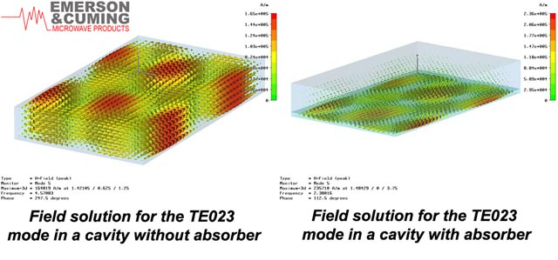
Figure 1. Shown here is the model of a cavity with and without an absorber. Note how energy is distributed throughout the cavity when it is empty but when the absorber is inserted, the energy resides in the absorber allowing the circuit to operate properly.

Cavity resonance occurs because standing wave modes and resonant frequency oscillations have the potential to exist inside a cavity within an enclosed space. These modes can exist in an empty rectangular cavity if the largest cavity dimension is greater than or equal to one-half of a free-space wavelength. Below this cutoff frequency, the cavity resonance cannot exist. For high frequencies or large cavities, multiple resonant frequencies can oscillate. As they do, they increase the likelihood that a device will radiate extraneous signals and cause the cavity to resonate.

The key parameter here is impedance. A standing wave inside a cavity causes the impedances in the cavity to vary. Consider, for example, that at the cavity walls (assuming a metallic or otherwise conductive wall) the transverse electric field, and therefore the impedance, will be zero. But just a quarter wavelength away - assuming no loss - the impedance becomes infinite. Depending on where the peaks and nulls of the voltage standing wave ratio (VSWR) occur, this phenomenon can adversely affect the input or output impedances of the device in questions. In other words, cavity resonance changes the impedance conditions required for proper operation of some circuit elements. In some cases, that change may result in the need to retune specific circuit elements. In the worst case scenario, it can even prevent circuit elements from working altogether.

With operational frequencies increasing, going higher into the microwave and millimeter-wave band, cavity resonance is rapidly becoming an ever more prevalent issue for circuit-board designers. Other factors contributing to the prevalence of this problem include increased circuit function, reduction in the physical size of microwave modules, and the need to enclose microwave circuit boards in metallic housings to provide shielding.

In many cases, designers fail to take this potential problem into consideration until late in the process – after the rigorous and costly design has been completed. By doing so, they leave themselves vulnerable to finding that their well-devised circuit board does not operate properly when it is integrated with the shield cavity (e.g., module cover) or chassis.

The Microwave Absorber
Preventative solutions for cavity resonance problems do exist, such as the use of standard shielding materials like finger stock, fabric-over-foam and board-level shields. While these solutions offer some safeguard against cavity resonance, they tend to become less effective as frequencies increase. Even worse, some of the more traditional shielding solutions (e.g., finger stock and conductive elastomers) can actually contribute to the resonance problem by providing a conductive path for energy, which in turn contains the energy inside the cavity. This contained energy can adversely affect other components on the board and may keep the board from functioning properly.

Even when circuit board designers are confronted with the likelihood of a cavity resonance problem in their design, they are often too time-constrained to take appropriate action. They simply don’t have the time required to go through the complex resonance modeling exercise necessary to select a viable material for their cavity.

For those designers who can no longer afford to approach the issue of cavity resonance with a passive attitude, an alternative solution is now available - use of microwave absorbers (blocks of materials which absorb microwave energy) applied directly to the cover of the microwave module. As opposed to having to re-engineer a circuit board cover or relocate circuit elements, the simple addition of the microwave absorber to the cavity provides an inexpensive, quick and proven way to dampen and even eliminate cavity resonance (see Figure 2).

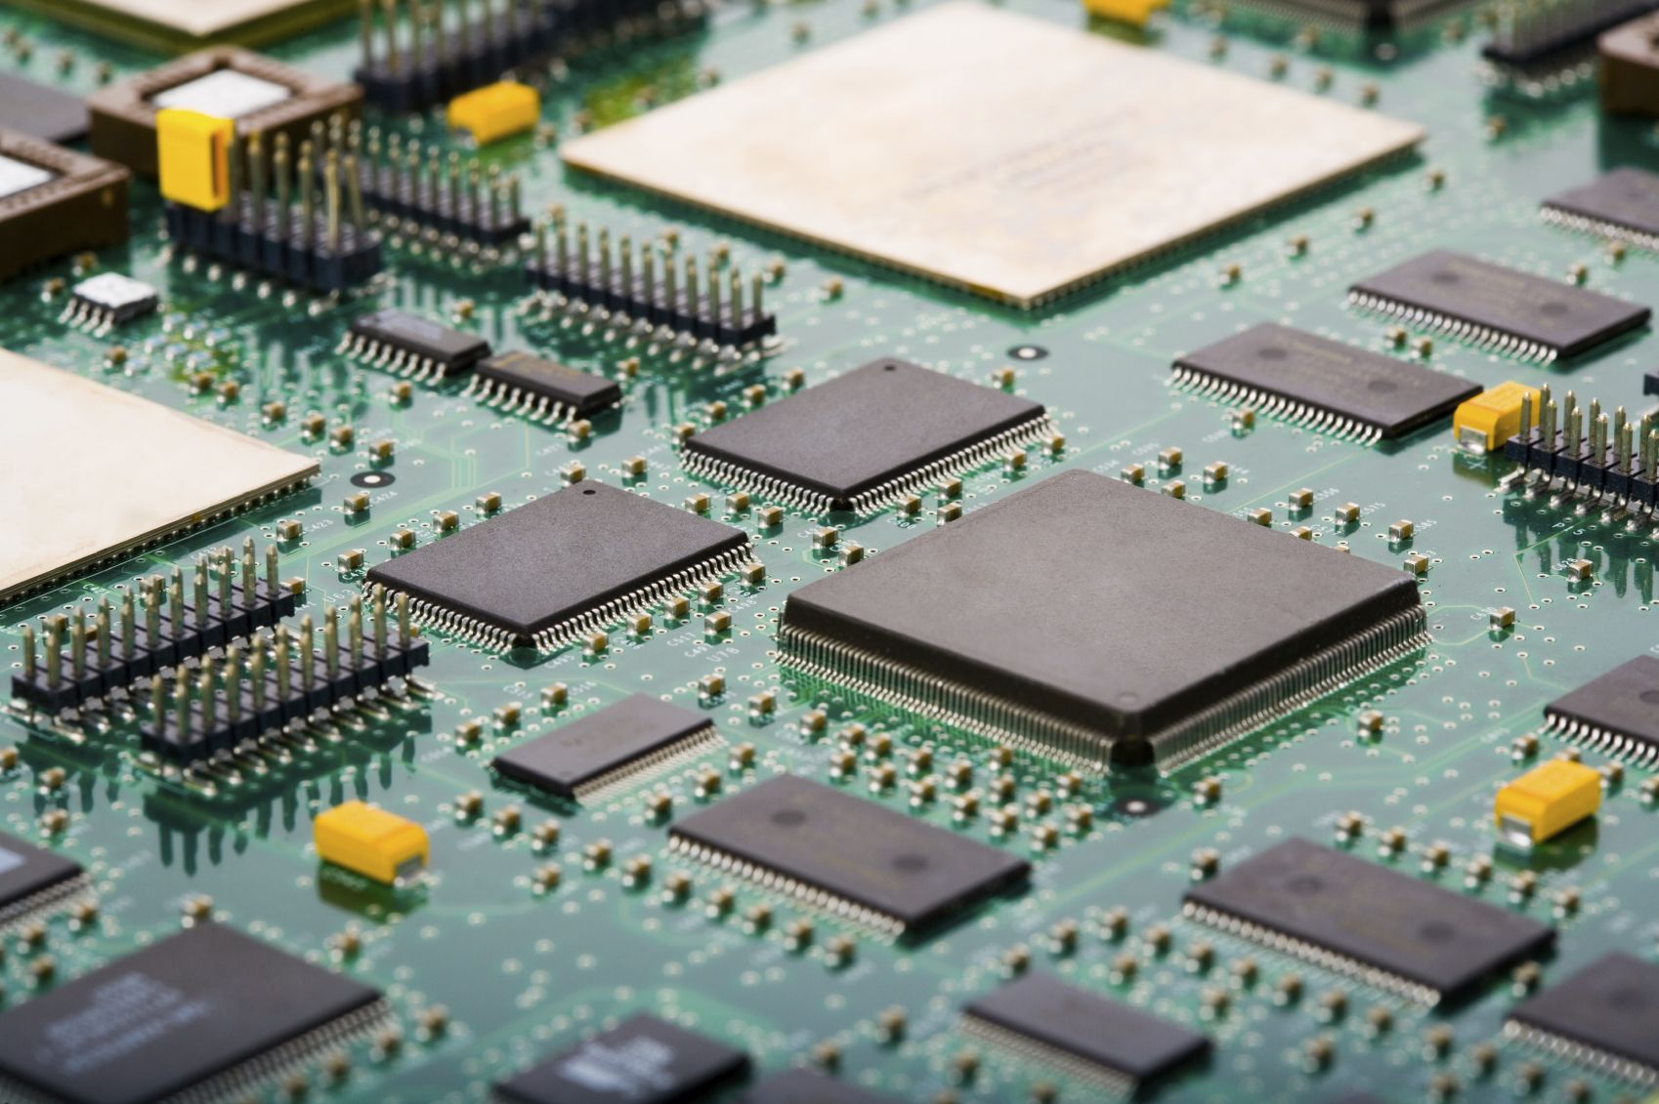
Figure 2. Use of a microwave absorber on the cover of a printed circuit board like the one pictured here provides a quick and cost-effective way to eliminate cavity resonance.

In general, the most effective absorbers (e.g., silicone rubber sheets) for cavity resonance dampening are magnetically loaded with iron or ferrites and are characterized by high permittivity and permeability plus a high magnetic loss. Material thickness is another important parameter, as the effectiveness of the resonance dampening is directly proportional to the thickness. The material’s effectiveness is also directly proportional to the frequency. Some materials will work better, for example, in the lower microwave range, while others will work better at the higher microwave and millimeter-wave range.

Thinner material is often used at higher frequencies. In fact, magnetic material at a thickness of around 0.040 inch has proven to be effective for use in the lower microwave range (up to 10 GHz), while 0.020 inch to 0.030 inch materials have been effective in the upper microwave range. In addition, 0.010-inch thick absorber materials are effective for the millimeter-wave bands.

Emerson & Cuming Microwave Products Value Proposition
Emerson & Cuming Microwave Products is a world leader in the development and manufacture of microwave absorbing materials. As a company strongly committed to addressing the complex issue of cavity resonance, it now offers a range of microwave absorber solutions - including foam and silicone rubber sheets - which are suitable for use in wireless and other high-frequency applications. These solutions include:

- Foam Dielectric Absorbers
Foam absorbers are the least expensive of all microwave absorber materials available on the market today and are often used in base stations. They are conductive and come no thinner than 1/8 inch, but if the circuit design can accommodate that material thickness and out-gassing is not an issue, then foam is often the ideal solution for eliminating cavity resonance.

  - ECCOSORB® LS – High Loss , Flexible, Foam Microwave Absorber
The ECCOSORB® LS absorber from Emerson & Cuming Microwave Products is the company’s most widely known, used and recommended urethane foam sheet product. It features high loss, low density, is very flexible, and can be easily cut with a knife, scissors or die. A carbon loading system makes it electrically conducive. While it is not weatherproof, it can be treated with an optional weather-resistant CERSEAL coating. Compared to thinner, more expensive rubber absorbers, ECCOSORB® LS is a very low cost solution which is useful in lowering cavity Q’s (high quality factors) in RF amplifiers, oscillators, cabinets containing microwave devices, computer housings, and low-noise blocks (LNBs).

- Silicone Rubber Sheets
Silicone rubber sheets are typically used for higher temperature applications where a non-conductive, high reliability, thin absorber (as thin as 0.010 inches) is required. Because of these characteristics, the military and aerospace industries commonly design in these absorbers for applications where out-gassing is also a concern.

  - ECCOSORB® BSR – High-Loss, Ultra-Thin, Elastomeric Absorber
This family of thin (0.25 to 2.54 mm) and flexible, high-loss absorbers is comprised of two types of electrically non-conductive silicone rubber sheets. ECCOSORB® BSR-1 and ECCOSORB® BSR-2 have a typical frequency range that will cover from 5 GHz well into the mm wave range and can be easily cut with a knife or scissors, and fitted to compound curves. Low out-gassing properties make the ECCOSORB® BSR family suitable for space applications. They have been specifically engineered for use in applications requiring the reduction or elimination of cavity resonance.

  - ECCOSORB® GDS – High-Loss Silicone Rubber Sheet
ECCOSORB® GDS is a thin, flexible, electrically non-conductive silicone rubber sheet with a typical frequency range of 6 GHz up to 35 GHz (see Figure 3). Designed to be impervious to moisture and to not support fungal growth as per MIL-STD-810E, these absorbers can be cut and fitted to compound curves. Low out-gassing properties make ECCOSORB® GDS suitable for space applications. When bonded to a metal surface, the absorbers dampen cavity resonances in microwave modules.

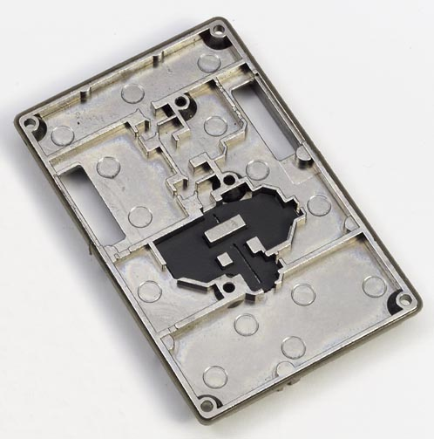
Figure 3. ECCOSORB® GDS is a moderately high-permeability silicone rubber material which can be added to a cavity, as shown here, to dampen cavity resonance.

  - ECCOSORB® MCS – Thin, Flexible Broadband Absorber
This thin, flexible, high-loss, magnetically-loaded, electrically non-conductive silicone rubber sheet has a frequency range from 800 MHz to 18 GHz (see Figure 4). ECCOSORB® MCS was designed to function continuously at a service temperature of 350°F, with short term exposure to higher temperatures, and is impervious to moisture. It can even be subjected to outdoor environments and high altitudes, including space, with no adverse effects. Its low out-gassing properties make it suitable for use in space applications. ECCOSORB® MCS can be cut and fitted to compound curves and is ideal for use in reducing cavity resonances in microwave modules.

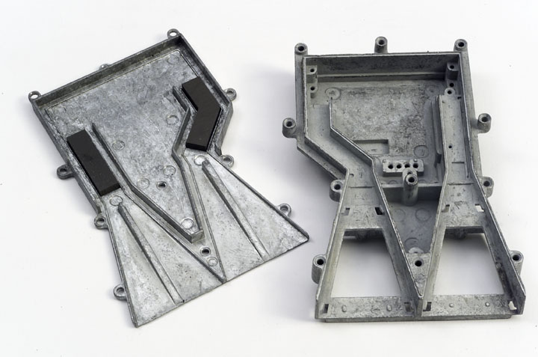

Figure 4. A thin, flexible broadband absorber like ECCOSORB® MCS exhibits a high permittivity and permeability, as well as magnetic loss tangent, making it ideal for cavity resonance dampening in military applications like radar systems.

Complementing the leading features and functionality of these microwave absorber materials is the unique value proposition offered by Emerson & Cuming Microwave Products. The company:

- Has a long history of excellence and expertise in making components for the military. It was founded in 1948 with this goal in mind.
- Offers the benefits associated with the infrastructure of a large company (e.g. R&D facilities etc…), but with the personal customer service and responsiveness of a small company.
- Was the first to become ISO certified (ISO 9001:2000) and to use automation in manufacturing. This automation increases yields up to 95-100%, ensures electrical consistency and enables the company to run upwards of 20,000 square feet of foam per day.
- Offers global manufacturing via facilities in Randolph, Massachusetts and Westerlo, Belgium with sales offices ad agents worldwide.
- Has state-of-the-art R&D facilities capable of rapid design and development with quick prototype turnaround and short production lead times.

Conclusion
With frequencies increasing faster than circuit board cavity sizes are decreasing - driven by the proliferation of wireless communications applications - the cavity resonance problem will only get worse. While the more traditional shielding solutions and clever engineering redesigns continue to provide some measure of protection against the effects of cavity resonance, there is a better alternative. Absorber materials like the silicone-based rubber sheets and dielectric foam from Emerson & Cuming Microwave Products now offer circuit designers the solution they need to quickly and cost-effectively eliminate both simple and complex cavity resonance.

For more information on this topic, visit Emerson & Cuming Microwave Products at www.eccosorb.com. For sales or technical inquires, email the Sr. Sales & Applications Engineer James DelPrete at jdelprete@eccosorb.com, respectively.

